Andrew Nelson
State machine
The state machine we used in our robot code has 2 main parts. DriveTask and AutonimousSM. DriveTask is called constantly and is responsible for all the motor outputs. We have a global structure, driveInfo, initialized that has a member modeDrive. ModeDrive is an int but we have a set of macros defined that map all the possible states, like DRIVEMODE_TURN, DRIVEMODE_DISTANCE and DRIVEMODE_STOPPED that map, to corresponding integer representations. Inside the DriveTask function, there's a switch statement that, depending on what modeDrive is set to, will run a corresponding algorithm to decide what to drive each motor at next and to check if it's done. If it is done, it'll call the function AutonimousSM which will check the numeric id of the state that just finished (usually the number state it is chronologically) and set the modeDrive member to a new state.
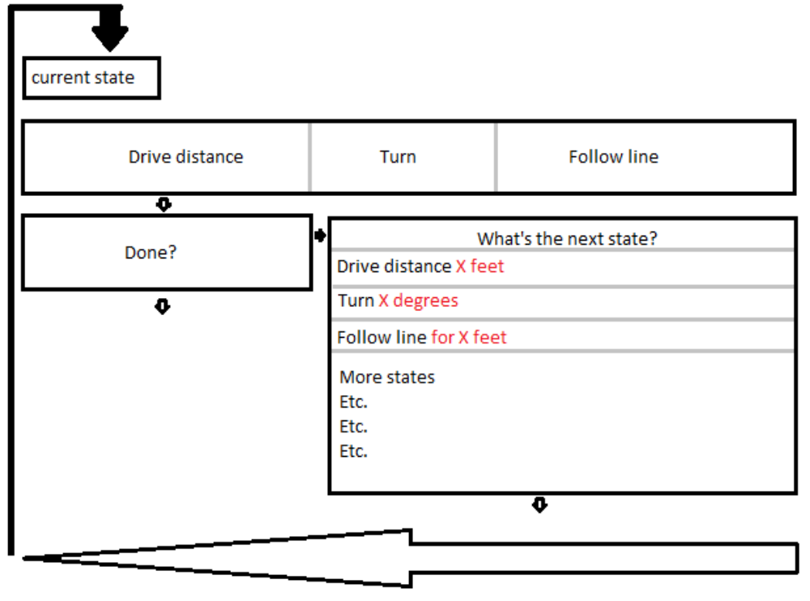
Below is a pictorial representation of the state machine:

